Chapter 16
Rethinking Blockchain and Machine Learning for Resource Constrained WSN
Nilesh P. Sable¹ Vijay U. Rathod²*

¹JSPM's Imperial College of Engineering & Research, Wagholi, Pune, India, drsablenilesh@gmail.com
²JSPM's Imperial College of Engineering & Research, Wagholi, Pune, India*, vijay.rathod25bel@gmail.com
Abstract. The focus of this chapter is on a type of ad-hoc networking, namely wireless sensor networks. Advances in hardware design, high-speed growth in the wireless network communications infrastructure, and increased user requirements for node mobility and regional delivery processes continue to create a massive demand for dynamic ad-hoc basis networking. A reliable routing structure is required to confirm the security and efficiency of wireless sensor networks (WSNs) routing. Various studies have been conducted to determine how to improve the reliability of routing nodes by using cryptographic applications, confidence management, or central routing solutions and among other methods. Conversely, the majority of routing patterns are problematic to implement in real-world scenarios because dynamically identifying untrustworthy routing nodes behavior is difficult. At the same time, there is no effective way to defend against attacks from malicious hosts. In light of the above issues, here writers advise a reliable routing arrangement for WSN that includes blockchain and reinforcement learning to continuously improve routing efficiency and security. Applying blockchain, a feasible routing mechanism for gaining routing evidence from routing nodes is presented, making routing information detectable and unalterable. The trained reinforcement model is used by routing nodes to dynamically select more efficient and reliable routing channels.
Keywords: Routing Algorithm, Blockchain, Reinforcement Learning, WSNs.
- Introduction
A WSN is a collection of sensor nodes that can communicate and interact to discover a physical environment using a wireless connection. To Convert these physical objects into equivalent electrical quantities, gross mechanical actions are transformed into subtle sensory responses by this WSN. The information gathered by the various sensor nodes is compiled and transmitted to the base station (BS). Memory unit, processor, power unit, sensor group, and transceiver are the five modules that make up the sensor node. Among these modules, the processor exercises command control. WSN's primary challenge is providing high throughput with incomplete network resources such as processing power, capacity of the transmission channel (i.e. bandwidth), and storage interplanetary.

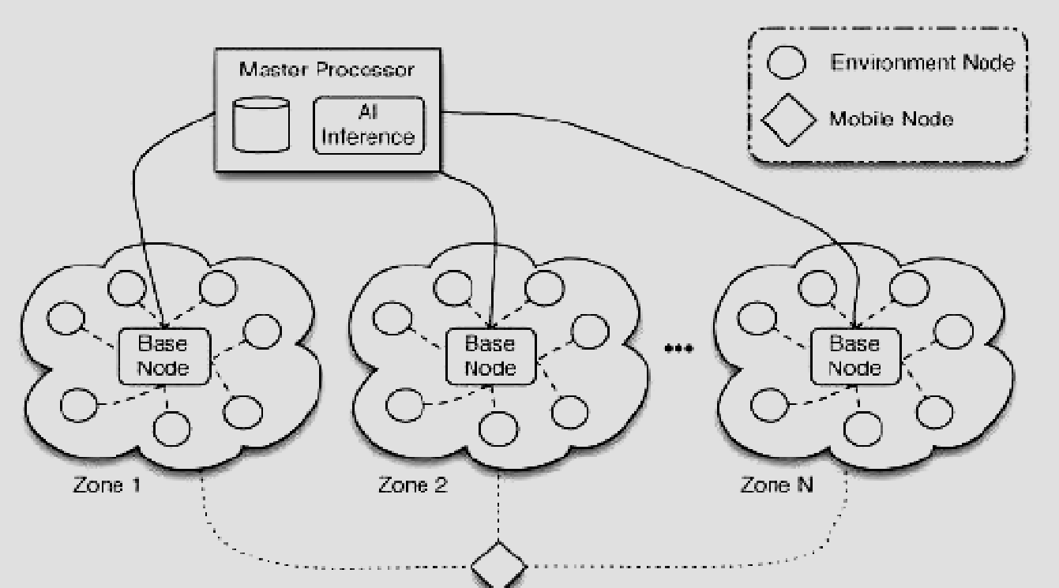

Figure 1: WSN's General Situation
WSNs can be used for a variety of applications. A maximum number of sensor nodes are installed in a hostile atmosphere. WSN nodes are energy constricted, finding it challenging to recharge the sensor nodes' energy sources once they are installed. One of the most promising strategies for trying to overcome the energy limitation issue is the routing algorithm used in the network. WSN routing algorithms are in charge of sustaining and determining the best routes in the network.
Experiments with wireless sensor networks (WSNs) have shown that sensors can be linked to an individual, such as objects, animals, or people, in order to keep a physical mobile under surveillance in its wireless network setting. Regardless of how the sensor nodes are powered, it's critical to use energy-efficient wireless network routing strategies to extend the sensor's life as much as possible.
The most significant issue with WSN design is the sensor node's battery energy, which is limited and consumed in a short period of time. In time-varying and dynamic wireless sensor network environments, it is critical to provide efficient wireless network routing schemes that distinguish malicious nodes. Because the radical change in routing evidence amongst two routing nodes is challenging to differentiate appropriately, existing routing strategies struggle to detect such abnormal nodes.
WSNs are a promising technology that uses a self-organizing network and a single and multi-relay to gather and send data to customers, with applications in military defense spending, atmospheric engineering, related industries, farmland intelligent systems, as well as other fields. WSN consists of an enormous amount of micro-combined sensor nodes that collaborate to comprehensive monitoring systems, awareness, and information gathering. One of the key WSN technological innovations is multi-hop routing, which is responsible for transmitting information gathered by sensor nodes from transmitter to receiver nodes using an agreed-upon routing algorithm. However, because of WSN's open, distributed, and dynamic nature, multi-hop routing is vulnerable to a diversity of attacks, cooperating with its safety and effectiveness. Traditional secure routing strategies, which are effectively set on the encryption algorithm and authentication methods, are unsuccessful for multi-hop decentralized WSNs.
Existing routing schemes are unable to distinguish malicious nodes in period-changing and dynamical WSN situations. Routing nodes in some routing algorithms are unable to distinguish between the truth and falsehood of routing evidence-free by other routing nodes. Figure 2 shows that an anomalous node can provide incorrect queue length information, increasing the likelihood of receiving a packet. This usually causes routing scheduling violations in other routing nodes. Because the actual-period alteration of routing evidence among two routing nodes is problematic to distinguish. Existing routing schemes have a hard time identifying such malicious nodes.
Once a suspicious node accepts packets of data from member nodes, rather than transmitting them to the next-hop member nodes, it throws away them immediately. This consequences in a data "black hole" in the system, thus the name "black hole attack," which is difficult to detect for routing nodes in WSNs. External attackers or inner appropriate nodes captured by outside attackers could be the malicious nodes.
Trust organization has recently become a widely used method of guaranteeing routing network security. Its main strategy is for each node to keep and experiment with a trust model that uses neighboring routing nodes faith values to make routing decisions. Based on the trust value, this method enables the routing node to select a relatively reliable routing link. Nevertheless, it can only obtain the faith values of its neighbors, which is incompatible with a multi-hop distributed WSN.

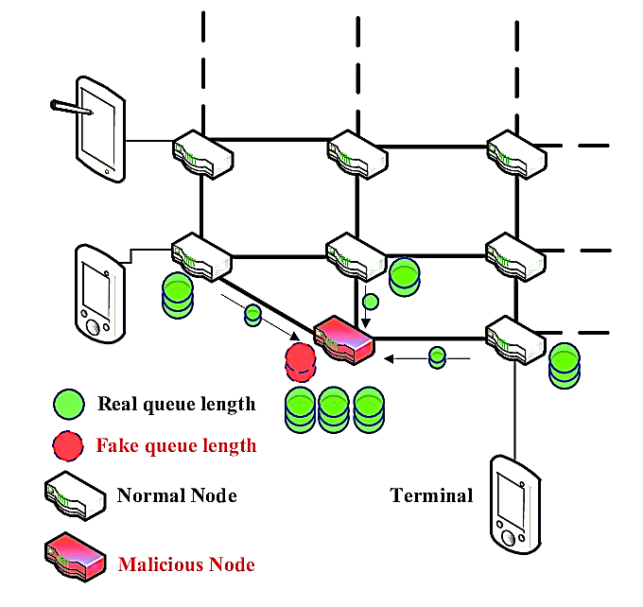

Figure 2: The Malicious Node in a Back-Pressure Routing Algorithm (BPRA).

Because of the aforementioned security concerns, a 3rd intermediate is being considered as a solution to the routing nodes belief delinquency; however the intermediary will be useless for multihop disseminated WSNs. In the meantime, malicious nodes are likely to attack and control a third party trust organization center, putting the system's security and fairness at risk. As a secure, autonomous, identity record system, the blockchain is well-suited to multihop decentralized sensor networks (SNs). A lot of study has been done in the past several seasons on using blockchain to routing techniques. The blockchain is a distributed ledger keeping up with the latest by numerous nodes that is mainly supposed to address trust and security issues.
Blockchain requires not only a lot of computing power, but also a lot of memory and communication. As a result, integrating blockchain into a sensor node is not just complicated but also difficult, unless cost cutting techniques for control and communication are established. Finding strategies to reduce the amount of storage used and, most significantly, the amount of computation used is a complicated task.
The cryptographic complexities of blockchain technology restrict its implementation in sensor nodes due to the limited resources that are available in sensor nodes. To take advantage of blockchain, however, an effort is made to design a private blockchain to avoid information manipulation, data damage or fabrication, and possible threats, intrusions, and data abuse.
In this chapter, designers introduce a new trusted routing technique for WSN applications based on blockchain and reinforcement learning. Designers deploy blockchain techniques to develop a decentralized routing data management system in which all routing data is stored on the blockchain via blockchain-token transactions (BTTs). To improve the reliability of route discovery across routing hubs, the technique makes use of the decentralized, unadulterated, and transparent qualities of blockchain activities. Reinforcement learning is used to learn the dynamic, reliable, and comprehensive routing information from the blockchain network. The dynamically updated reward value delivered by each state's activity forms a dynamically updated reinforcement learning model in each routing node. As an auxiliary routing node to make more reliable and efficient routing decisions and select more reliable and efficient routing links.
- Related Work

An old-fashioned confidential routing arrangement for enlightening routing security and reliability is reviewed in this section. Using blockchain technology, here we present the relevant research approaches for routing schemes. Finally, we look into the current state of reinforcement learning's application in routing systems.
2.1. Conventional Trustworthy Routing Systems
WSNs face a significant and difficult challenge in providing a trusted routing environment. There are numerous related studies that have been conducted in order to appliance a trustworthy routing structure. By expanding the popular ad hoc on demand distance vector routing protocol, Li et al. created an innovative trust-based routing protocol. The protocol uses a trust model to recommend reliable routing nodes and to enhance the security of the routing environment.
The majority of those researches are primarily based totally on a "recognition system," which assesses the person of different nodes so as to decide which path to take. However, constructing a reputation table necessitates knowledge of routing node behaviour in the past, which is insufficient to ensure WSN security in real time. Meanwhile, each routing node's reputation table may be altered with, making complete trustworthiness impossible to guarantee.
2.2. Blockchain Network-based Routing Mechanisms
Certain individuals have recently incorporated the data integrity and transparent characteristics of distributed ledger technology with routing techniques for increasing the level of trust between routing nodes. The approach replaces conventional public-key-infrastructure (PKI) with a blockchain system. Allowing for a decentralized inter-domain routing system by eliminating the need for central authentication. Individual integrated factor communication tree (IFT) algorithms and their behavioural characteristics vary. There are two types of routing nodes in blockchain-based communication: abnormal and normal. Smart contracts are used to aid routing nodes in establishing a secure path to destination nodes. On the smart contract, the source node acknowledges each hop's routing arrival and records malicious routing nodes with harmful behaviour. No more packets will transit through a known malicious node after then. A hostile node possessing Bitcratic Revenue (BCTR) tokens, on the other hand, could falsely claim to have received the packets, putting the scheme at risk.
2.3. Routing Approaches with Reinforcement Learning Algorithms
It is challenging to employ dynamically routing information successfully in WSN routing infrastructures. An identification routing set of rules is wanted for such dynamic routing environments. In order to boom the recognition of routing techniques, Boyan et al. were the first to use the Q-learning algorithm in conjunction with packet routing to learn the routing environment dynamically and find the shortest path. By mining complicated, dynamically updated routing network information, reinforcement learning can be utilized to enhance routing scheduling algorithms. The conventional backpressure routing set of rules has confined routing records of neighbouring routing nodes. As seen in Figure 3, the loop routing problem occurs, causing a substantial delay in the entire routing process.

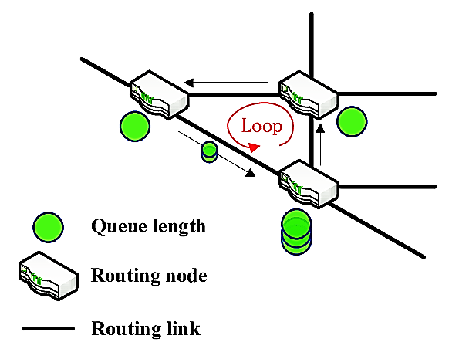

Figure 3: Routing Algorithms Have a Loop Routing Problem
- Using Blockchain and Reinforcement Learning Mechanisms to Improve Communication Network Routing Security and Efficiency in WSNs
A precise routing arrangement is much more beneficial for ensuring the routing effectiveness and security of WSNs. A large number of readings are being conducted to demonstrate trust between two wireless network routing nodes (WNRNs), a decentralisation point (DP), cryptographic systems (CSs), trust management (TM), centralised routing decisions (CRDs), and other entities. Many other routing systems, on the other hand, are difficult to implement in real-world applications because dynamic differentiation between trusted and untrusted routing node behaviours is difficult. Meanwhile, it appears that preventing malicious node attacks effectively is proving to be a difficult task.
In terms of challenges, this research suggests that using blockchain and reinforcement learning approaches, a trustworthy routing technique can be used to improve the effectiveness and safety of routing for wireless sensor networks. On the blockchain technology, an actual-world wireless network routing (WNR) methodology is made available to obtain network routing information from network routing nodes, creation the data detectable and enormously problematic to change. The reinforcement learning process is employed to assist system routing nodes in dynamically selecting more accurate and competent channel routing links.

  - Blockchain Technology
As a new module, the blockchain makes a significant contribution to the security of the WSNs through its features. Should provide information integrity in a blockchain and traceability. Between the chains or peers, the blockchain creates consensus. The consensus process is carried out independently using data status rules, contributing to the system's full independence. In completely truthful blockchain technology, there are five main components, i.e. distribution, encryption, immutability, tokenization and decentralization.
Distribution: The contributions to blockchain are completely separated from each other and are connected to the network. A comprehensive version of the Ledger that changes new transactions even though those who appear are managed to maintain a complete node within each contributing factor. In a production process, a distribution network is responsible for the data of warehouses and transport systems that receive inventory levels of goods and deliver them to the customer after any event.
Encryption: Public and private keys are being used by blockchain technologies to safely and semi-anonymously record all the information within blocks. Contributions will regulate about their authenticity as well as other private details and will communicate only what they're doing in a transaction.
Immutability: Comprehensive operations in the block chain are cryptographic-ally agreed to sign, time-stamped and added to something like the ledger by forming as well as following a logical order as well as a sequence. Unless the participants agree on the need to do so, records in the blockchain technology cannot be corrupted or otherwise modified.
Tokenization: A protected exchange of value in emerging blockchain technologies involves transactions as well as other interactions. Valuation comes as a result of tokens in blockchain, but it can represent anything from financial instruments to data to tangible infrastructure. The coupons as well approve contributions, a foundational driver of the business plan of the blockchain, to control their personal data.

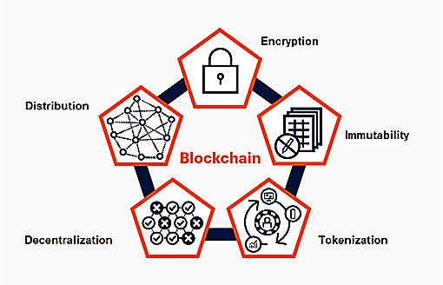

Figure 4: Illustration of Blockchain Technology

Decentralization: In this, due to a competition mechanism, both wireless network information and the guidelines for how the wireless network works are kept by nodes on the distributed platform. De-centralization implies that no central authority, as in the wireless atmosphere line of work, controls all the wireless networking nodes or indeed the data, as well as governs the rules. In its simplest form, when two or more nodes are connected and share network resources without going through a separate server computer, a decentralized network is created. An ad hoc connection may be a decentralized platform.
A blockchain is an understandable, distributed wallet that records information on a peer to peer (P2P) network of both public and private peers. In wireless-ad-hoc-networking, block-chain operates as a central source of wisdom, and representatives of a public blockchain can only display these transaction records suitable for each other.

  - Routing Algorithm based on Reinforcement Learning and Blockchain
Routing multicast nodes creative and expressive more genuinely honest and successful routing links with the use of a reinforcement learning approach. Develop a comprehensive reinforcement learning routing scheduling algorithm for the blockchain-based-network-architecture (BNA) that is categorized as a routing algorithm that uses both reinforcement learning and block chain technology. To aid the routing node in selecting the next best routing node, the reinforcement learning technique is employed.
Because of the dynamic getting to know nature of the nodes, the routing set of rules primarily based totally on reinforcement getting to know method lets in for routing option. The block-chain approach is used to record each hop of routing information in this case. The link is irregular or the transmission rate is extremely low if the hop is looped. The technique effectively decreases the possibility of packets passing through the connection. Simultaneously, the routing set of rules can dynamically find out some distance greater reliable and well-deliberate routing hyperlinks on the way to help routing nodes in making an awful lot higher routing decisions. In this, an authenticated server node keeps each token transaction on the blockchain technology record; such that the quality of the transaction recorder's origin is backed up on all network routing nodes and server nodes.
By communicating trusted peers with municipal stakeholders, the framework allows transparent, safe and reliable transaction infrastructures that speed up digital services. Uses blockchain technology to authenticate device identity, protect sensor data used in transportation, and manage access to city facilities with the assistance of blockchain approach for advanced security against cyber-attacks and fraud. In blockchain, the block structure is as shown in Figure 5.
Similar to how a linked list is generated, a blockchain is a mechanism that links blocks to form a chain. A block header and content are the two main components of each block. The block header contains information about managing blocks and chains. On the other hand, the block body contains a list of transactions. Because the blockchain is a decentralized platform, nodes connect via a P2P network and validate transactions with their own digital signatures. In addition, some nodes maintain a ledger that contains a list of agreed blocks. Proof-of-Work (PoW) and Proof-of-Stake (PoS) are two consensus algorithms commonly used in block chain to keep the data on the ledger in sync.

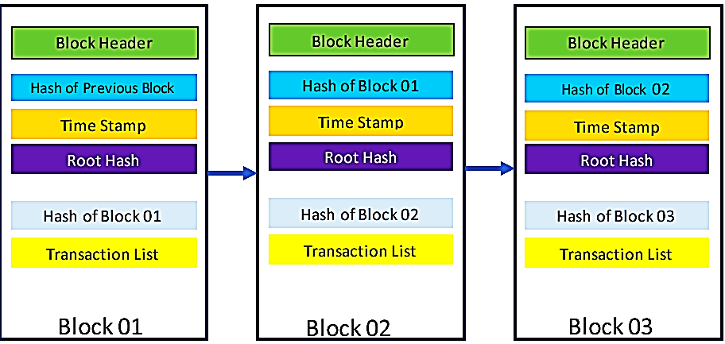

Figure 5: Block Structure in Blockchain Technology

The block header and block content are the two most significant components of each block. Figure 6 presents the significant sectors of the block header. To generate a root hash value from each block's transactions and check the integrity of the transactions within the block, blockchain technology employs a Merkle tree. A Merkle tree divides blocks transactions into pairs, with each transaction's hash recorded in a parent node. One step up the tree, the hashes of the parent nodes are preserved and arranged in pairs. This technique is repeated until you reach the root node.
A Merkle tree is a type of hash tree. Each leaf (node) of a Merkle tree is labeled with the cryptographic hash of the data block. Non-leaf nodes (also known as branches, interior nodes, or inodes) are tagged with the cryptographic hash of their child nodes label. The contents of a large data structure can be quickly and securely verified using a hash tree. Hash trees combine hash lists and hash chains to form hash trees. A list of transactions is contained in the block body. Digital signatures are used to verify each transaction.

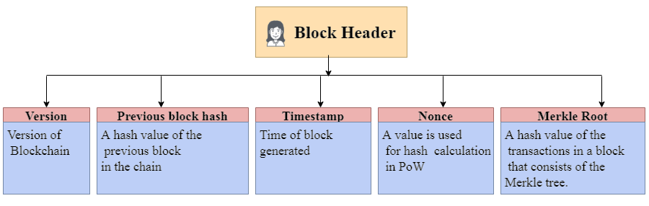
Figure 6: The Block Header's Most Important Elements

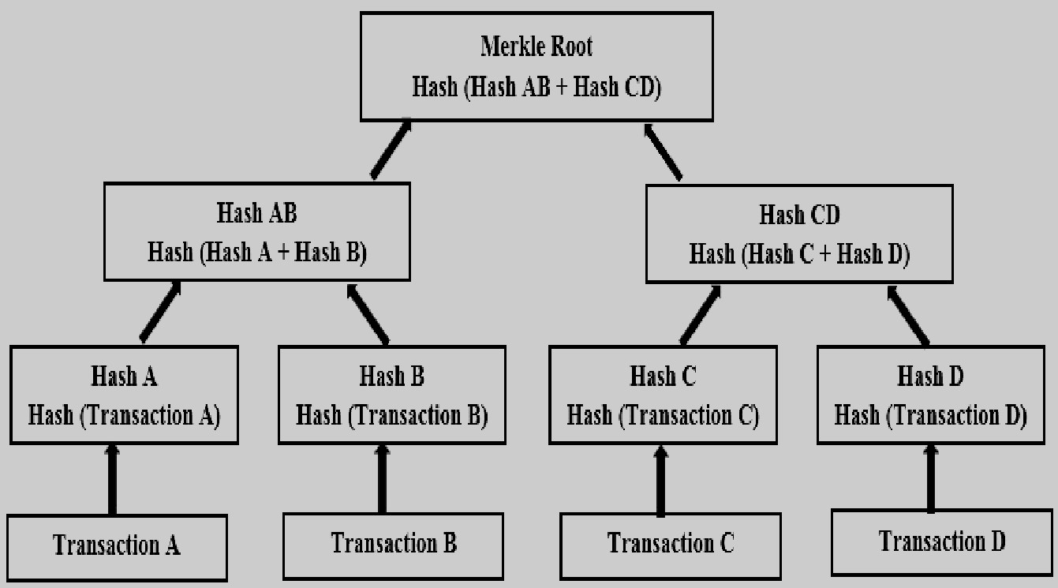

Figure 7: The Markle Tree
  - Blockchain Network Procedure

In order to function the blockchain-primarily based totally routing community structure successfully, the routing community`s statistics need to be transmitted to the blockchain community. Smart contracts are used to store the routing information. Like blockchain transactions like registration-contracts (RCs), token-contracts (TCs), and token-transactions (TTs), as shown in Figure 8. The server nodes verify all of these contents before publishing them to the blockchain.

The nodes of the authenticated server manipulate all smart contracts. The results of the execution are then returned to the blockchain network. All routing nodes' identities are recorded in the registration contract. To make it easier to query the entire network node, there are server nodes. The first algorithm explains the technique for creating the registration contract. Mapping maps are variables built into registration contracts that track how blockchain addresses are translated into physical addresses. Allocation status is a built-in variable that indicates whether a node is registered. When a new node wants to join a subscription contract, it must first invoke the contract.

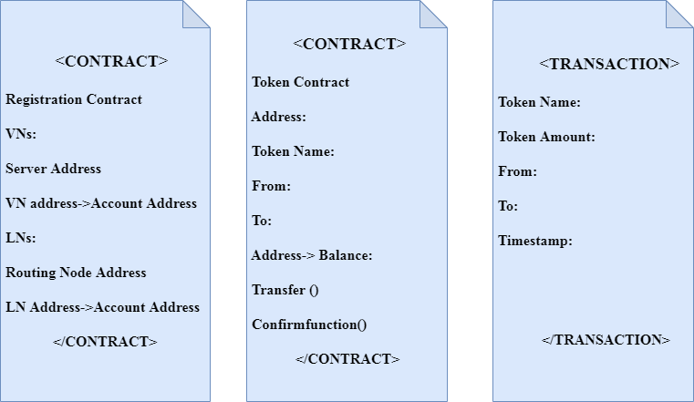
(a) (b) (c)

Figure 8: Formats for Smart-Contracts (SCs) and Blockchain-Transactions (BTs). (a) Registration-Contract. (b) Token-Contract. (c) Token-Transaction.

It then enters its data. Then he gives his physical address (pa) as identification information. The subscription contract immediately registers its blockchain address (ba). Whether (ba) is present in the state mapping is determined by the registration contract. The registration contract correctly stores the map (ba->pa) in the (map) mapping and the map (ba ->1) in the (state) array when (state = 0). If (status=1) indicates that the node is registered, this action will result in failure. The code's logic links the node's blockchain address to the identity, and once registered, the information cannot be modified.

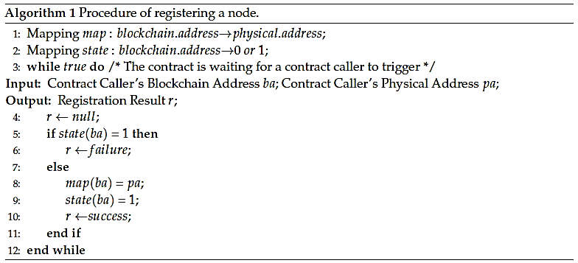

Figure 9: Procedure for registering a node (Algorithm 1)

In this section, users extend reinforcement learning-based routing planning by using comprehensive, dynamic, and reliable routing information provided by the recommended blockchain platform. The correct blockchain-based reinforcement learning (RLBC) algorithm is summarized in Algorithm 2.
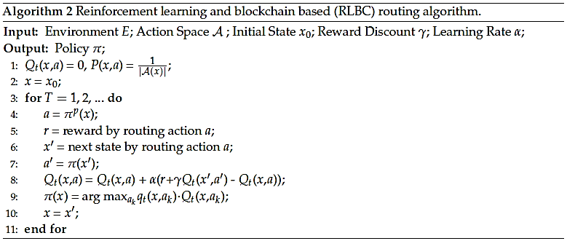

Figure 10: Algorithm 2: Reinforcement Learning and Blockchain-based Routing Algorithm (RLBC)

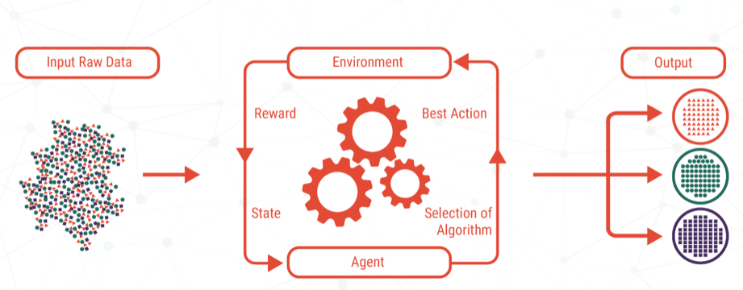

Figure 11: Illustration of Reinforcement Learning Technology

In computer science, reinforcement learning (RL) techniques are really a subfield of machine learning worried with the appropriateness of software agents to act decisively in an atmosphere to achieve maximum the concept of aggregation reward. One of the most significant techniques of the three basic machine learning modes, alongside supervised learning and unsupervised learning, is the reinforcement learning technique. The RL model is used to dynamically select the proper route discovery and avoid routing connections with malicious users. The RL based routing scheduling algorithm (RSA) uses the entire global, innovative and confidential routing information obtained from the suggested public block-chain.
- Advantages
Reinforcement learning and a blockchain-based routing algorithm are used to solve this problem. Increase the overall efficacy and safety of WSN routing. In addition to obtaining routing information from block chain routing nodes, a realistic wireless network routing concept is provided. This makes routing information traceable and makes it impossible to make necessary changes to data from a wireless network (WN).
- Applications

Seismic stations, civil, battlefield surveillance, health surveillance, habitat monitoring, home automation, and traffic control are some of the applications for wireless sensor networks. WSNs of satellites could be built for emergency applications such as disaster management, rescue operations, and broadband communications in areas where no infrastructure is available.

- Conclusions

To create a secure routing environment and boost the routing network's performance. In this chapter, authors projected a trust routing approach based on blockchain and reinforcement learning. The blockchain network, as a decentralised system, offers a viable method for routing information management and a platform for routing scheduling reinforcement learning. The routing packets are represented by the blockchain token. After the validation node authenticates each routing transaction, it is released to the blockchain network. Making each routing transaction recorder alter-impermeable and traceable. Routing nodes on the blockchain network can acquire dynamic and reliable routing information. The author also describes a thorough reinforcement learning algorithm to determine the optimal routing path and avoid routing links on malicious nodes.
References
- Kumar, K., Kumar, S., Kaiwartya, O., Kashyap, P., Lloret, J. and Song, H., “Drone assisted Flying Ad-Hoc Networks: Mobility and Service oriented modeling using Neuro-fuzzy”,Ad Hoc Networks, 106, p.102242, 2020.
- A. Kulkarni, A. Seetharam, A. Ramesh and J. Herath, "DeepChannel: Wireless Channel Quality Prediction Using Deep Learning", IEEE Transactions on Vehicular Technology, vol. 69, no. 1, pp. 443-456, 2020.
- T. Rahman, I. Ullah, A. Rehman and R. Naqvi, "Notice of Violation of IEEE Publication Principles: Clustering Schemes in MANETs: Performance Evaluation, Open Challenges, and Proposed Solutions", IEEE Access, vol. 8, pp. 25135-25158, 2020.
- D. Gaikwad and A. Mukeri, "Fine Tuned Deep Neural Networks for Intrusion Detection System", Journal of Network Security Computer Networks, vol. 06, no. 02, pp. 9-16, 2020.
- H. Sharma, A. Haque and Z. Jaffery, "Maximization of wireless sensor network lifetime using solar energy harvesting for smart agriculture monitoring", Ad Hoc Networks, vol. 94, p. 101966, 2019.
- J. Yang, S. He, Y. Xu, L. Chen and J. Ren, "A Trusted Routing Scheme Using Blockchain and Reinforcement Learning for Wireless Sensor Networks", Sensors, vol. 19, no. 4, p. 970, 2019.
- F. Khan, A. Gumaei, A. Derhab and A. Hussain, "TSDL: A Two-Stage Deep Learning Model for Efficient Network Intrusion Detection", IEEE Access, vol. 7, pp. 30373-30385, 2019.
- M. Ozturk, M. Gogate, O. Onireti, A. Adeel, A. Hussain and M. Imran, "A novel deep learning driven, low-cost mobility prediction approach for 5G cellular networks: The case of the Control/Data Separation Architecture (CDSA)", Neurocomputing, vol. 358, pp. 479-489, 2019.
- M. Zhang, B. Xu, X. Li, M. Yin, B. Wu and K. Qiu, "Deep neural network-based soft-failure detection and failure aware routing and spectrum allocation for elastic optic networks", Optical Engineering, vol. 58, no. 06, p. 1, 2019.
- B. Sahoo, T. Amgoth and H. Pandey, "Particle swarm optimization based energy efficient clustering and sink mobility in heterogeneous wireless sensor network", Ad Hoc Networks, vol. 106, p. 102237, 2020.
- D. Ergenç, L. Eksert and E. Onur, "Dependability-based clustering in mobile ad-hoc networks”, Ad Hoc Networks, vol. 93, p. 101926, 2019.
- S. Bhunia, M. Khan, M. Yuksel and S. Sengupta, "In-band LOS discovery using highly directional transceivers", Ad Hoc Networks, vol. 91, p. 101875, 2019.
- Y. Zhou, C. Shen and M. van der Schaar, "A Non-Stationary Online Learning Approach to Mobility Management", IEEE Transactions on Wireless Communications, vol. 18, no. 2, pp. 1434-1446, 2019.
- M. Han and Y. Kim, "Efficient Implementation of Multichannel FM and T-DMB Repeater in FPGA with Automatic Gain Controller", Electronics, vol. 8, no. 5, p. 482, 2019.
- D. Lynch, M. Fenton, D. Fagan, S. Kucera, H. Claussen and M. O'Neill, "Automated Self-Optimization in Heterogeneous Wireless Communications Networks", IEEE/ACM Transactions on Networking, vol. 27, no. 1, pp. 419-432, 2019.
- N. Pham, S. Fomel and D. Dunlap, "Automatic channel detection using deep learning", Interpretation, vol. 7, no. 3, pp. SE43-SE50, 2019.
- F. Aina, S. Yousef and O. Osanaiye, "RAAC: A bandwidth estimation technique for admission control in MANET", Facta universitatis - series: Electronics and Energetics, vol. 32, no. 3, pp. 463-478, 2019.
- K. Darabkh, M. El-Yabroudi and A. El-Mousa, "BPA-CRP: A balanced power-aware clustering and routing protocol for wireless sensor networks", Ad Hoc Networks, vol. 82, pp. 155-171, 2019.
- K. Fang, L. Ru, Y. Yu, X. Jia and S. Liu, "An energy balance and mobility prediction clustering algorithm for large-scale UAV ad hoc networks", Engineering review, vol. 39, no. 1, pp. 1-10, 2019.
- D. Ergenç, L. Eksert and E. Onur, "Dependability-based clustering in mobile ad-hoc networks", Ad Hoc Networks, vol. 93, p. 101926, 2019.
- M. Alabdullah, B. Atiyah, K. Khalaf and S. Yadgar, "Analysis and simulation of three MANET routing protocols: A research on AODV, DSR & DSDV Characteristics and their performance evaluation", Periodicals of Engineering and Natural Sciences (PEN), vol. 7, no. 3, p. 1228, 2019.
- H. Xu, Y. Zhao, L. Zhang and J. Wang, "A Bio-Inspired Gateway Selection Scheme for Hybrid Mobile Ad Hoc Networks", IEEE Access, vol. 7, pp. 61997-62010, 2019.
- B. Geng, "Traffic prediction and transmission scheduling of artificial intelligence-driven cognitive wireless networks", International Journal of Computers and Applications, pp. 1-9, 2019.
- F. Jiang, Z. Yuan, C. Sun and J. Wang, "Deep Q-Learning-Based Content Caching With Update Strategy for Fog Radio Access Networks", IEEE Access, vol. 7, pp. 97505-97514, 2019.
- S. Blakeway, A. Kirpichnikova, M. Schaeffer and E. Secco, "Transmission Power and Effects on Energy Consumption and Performance in MANET", ICST Transactions on Mobile Communications and Applications, vol. 5, no. 16, p. 159336, 2019.
- B. Jang, M. Kim, G. Harerimana and J. Kim, "Q-Learning Algorithms: A Comprehensive Classification and Applications", IEEE Access, vol. 7, pp. 133653-133667, 2019.
- J. Iqbal, A. Umar, N. Amin and A. Waheed, "Efficient and secure attribute-based heterogeneous online/offline signcryption for body sensor networks based on blockchain", International Journal of Distributed Sensor Networks, vol. 15, no. 9, p. 155014771987565, 2019.
- D. Sah and T. Amgoth, "A novel efficient clustering protocol for energy harvesting in wireless sensor networks", Wireless Networks, vol. 26, no. 6, pp. 4723-4737, 2020.
- M. Alsharif, S. Kim and N. Kuruoğlu, "Energy Harvesting Techniques for Wireless Sensor Networks/Radio-Frequency Identification: A Review", Symmetry, vol. 11, no. 7, p. 865, 2019.
- M. Shi and X. Wang, "Design of Hybrid Energy Harvesting Self-Powered Power Supply for Transmission Line Sensor", IOP Conference Series: Earth and Environmental Science, vol. 440, p. 032091, 2020.
- M. Al-kahtani, L. Ferdouse and L. Karim, "Energy Efficient Power Domain Non-Orthogonal Multiple Access Based Cellular Device-to-Device Communication for 5G Networks", Electronics, vol. 9, no. 2, p. 237, 2020.
- S. Whitfield, "Will Blockchain Become the New Operational Backbone in Energy?” Journal of Petroleum Technology, vol. 70, no. 05, pp. 30-33, 2018.
- D. Nguyen, P. Pathirana, M. Ding and A. Seneviratne, "Blockchain for 5G and beyond networks: A state of the art survey", Journal of Network and Computer Applications, vol. 166, p. 102693, 2020.
- Y. Zeng, H. Gu, W. Wei and Y. Guo, "$Deep-Full-Range$: A Deep Learning Based Network Encrypted Traffic Classification and Intrusion Detection Framework", IEEE Access, vol. 7, pp. 45182-45190, 2019.
- B. Wei et al., "A Deep-Learning-Driven Light-Weight Phishing Detection Sensor", Sensors, vol. 19, no. 19, p. 4258, 2019.
- S. Kasongo and Y. Sun, "A deep learning method with wrapper based feature extraction for wireless intrusion detection system", Computers & Security, vol. 92, p. 101752, 2020.
- X. Li and S. Zhang, "Network Intrusion Detection Methods Based on Deep Learning", Recent Patents on Engineering, vol. 14, 2020.
- M. Chanu, "A Deep Learning Approach for Object Detection and Instance Segmentation using Mask RCNN", Journal of Advanced Research in Dynamical and Control Systems, vol. 12, no. 3, pp. 95-104, 2020.
- B. Yu et al., "Weakly Supervised Deep Learning for the Detection of Domain Generation Algorithms", IEEE Access, vol. 7, pp. 51542-51556, 2019.
- V. Mutombo, S. Lee, J. Lee and J. Hong, "EER-RL: Energy-Efficient Routing Based on Reinforcement Learning", Mobile Information Systems, vol. 2021, pp. 1-12, 2021.
- "Blockchain Based Packet Delivery Mechanism for WSN", International Journal of Recent Technology and Engineering, vol. 8, no. 2, pp. 1112-1117, 2019.
- A. Baldominos and Y. Saez, "Coin.AI: A Proof-of-Useful-Work Scheme for Blockchain-Based Distributed Deep Learning", Entropy, vol. 21, no. 8, p. 723, 2019.
- C. Schinckus, "Proof-of-work based blockchain technology and Anthropocene: An undermined situation?”, Renewable and Sustainable Energy Reviews, vol. 152, p. 111682, 2021.
- H. TIAN, Y. QIN, T. ZHENG and D. GAO, "Implementation of intelligent infrared control node in wireless sensor networks", Journal of Computer Applications, vol. 30, no. 9, pp. 2549-2552, 2010.
- C. LIU, H. ZHANG and G. BAI, "Node deployment of wireless sensor network based on glow-worm swarm optimization algorithm", Journal of Computer Applications, vol. 33, no. 4, pp. 905-907, 2013.

